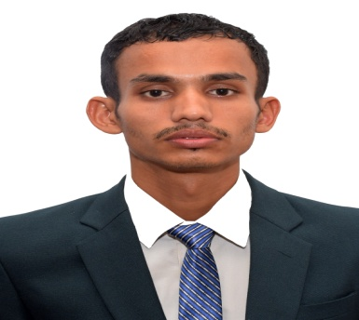**MR. SNEHASHISH PANDA**

**Mob. No: (+91)8328979779**

**Gmail id:**[**pandasnehashish97@gmail.com**](pandasnehashish97@gmail.com)

**CAREER OBJECTIVES**

I want to pursue a rewarding career in the field of Finance & Marketing where I can utilize my knowledge and skills efficiently both for organization as well as my personal growth.

**ACADEMICS**

**PROFESSIONAL QUALIFICATION**

**2018-20:** Completed Master of Business Administration(MBA)at Astha School of Management, Bhubaneswar affiliated with Biju Pattnaik University of Technology(BPUT),Odisha & approved by All India Council for Technical Education(AICTE),New Delhi.

**College Qualification**

**2014-17:** Passed B.COM (Banking & Insurance. Hons) from Bhadrak Auto.College,Bhadrak

**GENERAL QUALIFICATION**

**2012-14 :** Passed Intermediate in Commerce fromUpendra Nath Junior College,Soro,Balasore

**2012:**Passed Matriculation from Narasingha pur High school,Bhadrak,Odisha

**TECHNICAL QUALIFICATION:** PGDCA,EXCEL.

## **EXPERIMENTAL LEARNING**

* **Summer Internship Program:** Completed 60days of Summer Internship Program at IDBI BANK Ltd. on the topic of “Loans and Advances of IDBI BANK Ltd.”

**Live Project**

* Did 10 days business model program at Durga puja committee in Bhadrak.
* Did a field on the topic of Child Labour Awareness program with visiting different colleges in Bhubaneswar.

**Achievement**

Achieve certificate in business quiz conducted in SOA University ,2019

**SKILLS**

Strong Analytical, Organizational Ability, Ability to perform well under pressure

**PERSONAL DETAILS**

Date Of Birth : 20th Jun 1997

Father’s Name : Mr Gadadhar Panda

Mother’s Name : Mrs Nandini Panda

Permanent Address : At/Po-NarasinghaPur, PS-Basudev Pur, Dist-Bhadrak, Pin-756168,Odisha

Hobbies :Reading News Paper, Reading G.K, Visiting New places

Strength & :Quick leanring, Ability to complete any job successfully & Leadership. Quality. Good Analytical Quality.

Language :English ,Odia &Hindi

Aadhar Card NO : **2480 1958 1130**

PAN NO :**EJCPP7525L**

**DECLARATION**

I do hereby declare that all the information provided above by me is true to the best of my knowledge and belief.

**DATE : Signature :**

**PLACE :**